**DEVICE DRIVERS**

**PROJECT REPORT**

**PROJECT TITLE-ACCELEROMETER ATMEGA8 USING USB**

**Submitted by**

**SHYAM KRISHNAN K V**

**A SIDDARTHA**

* **SUMMARY-**
* **COMPONENTS USED**

1. ADXL335 ACCELEROMETER
2. ATMEGA 8 MICROCONTROLLER
3. USB
4. CONNECTING WIRES AND BREADBOARDS
5. RESISTORS,CAPACITORS AND ZENER DIODES

**1.ADXL335-**An accelerometer(ADXL335) is an electromechanical device that will measure acceleration force. It shows acceleration, only due to cause of gravity i.e. g force. It measures acceleration in g unit. It can be used for tilt sensing applications (Example: In mobile phones, gaming applications etc).The ADXL335 measures acceleration along X, Y and Z axes. It gives analog voltage output proportional to the acceleration along the 3 axes. These voltages can be converted to digital signal using ADC and then processed by microcontroller to find out the tilt. Features of ADXL335 are as follows:-

1. 3V-6V DC Supply Voltage
2. Onboard LDO Voltage regulator
3. Can be interface with 3V3 or 5V Microcontroller.
4. All necessary Components are populated.
5. Ultra Low Power: 40uA in measurement mode, 0.1uA in standby@ 2.5V
6. Tap/Double Tap Detection
7. Free-Fall Detection
8. Analog output

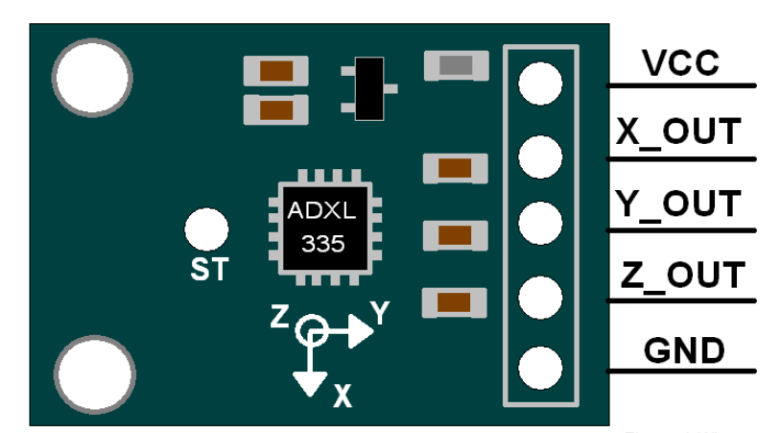

**ACCELEROMETER ADXL335**

1.VCC:Power supply pin

2. X_OUT:X axis analog output

3. X_OUT:Y axis analog output

4. X_OUT:Z axis analog output

**2.ATMEGA 8A Microcontroller-**

1.**ATmega8** is an 8-bit AVR microcontroller that is based on RISC architecture and is mainly used in the embedded system and industrial automation projects.

2.The Program memory is 8K Flash, enough to store a number of instructions while other two memories RAM and EEPROM contain 1K and 512 Bytes respectively.

3.Other features of this module include are a power-up timer, a watchdog timer, Brown out Detection, In-Circuit Serial Programming and five sleep modes.

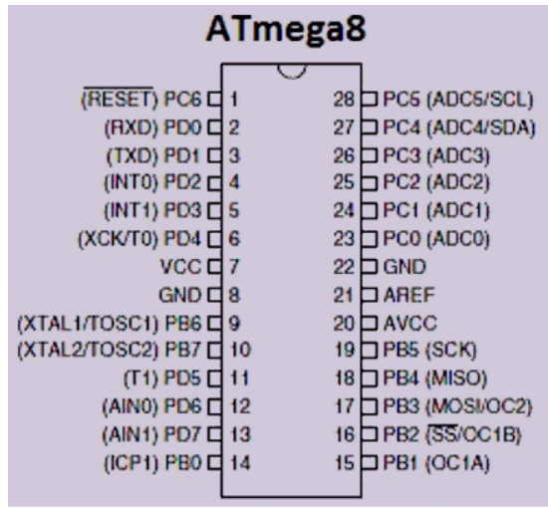

**ATMEGA 8 MICROCONTROLLER**

**Accelerometer** device can be implemented over low cost **USB hardware** and data can be reported back to kernel through Input Subsystem. These events reported to Input Core can be further used to provide user space application.

* **HARDWARE DESIGN**

**1.SCHEMATIC**

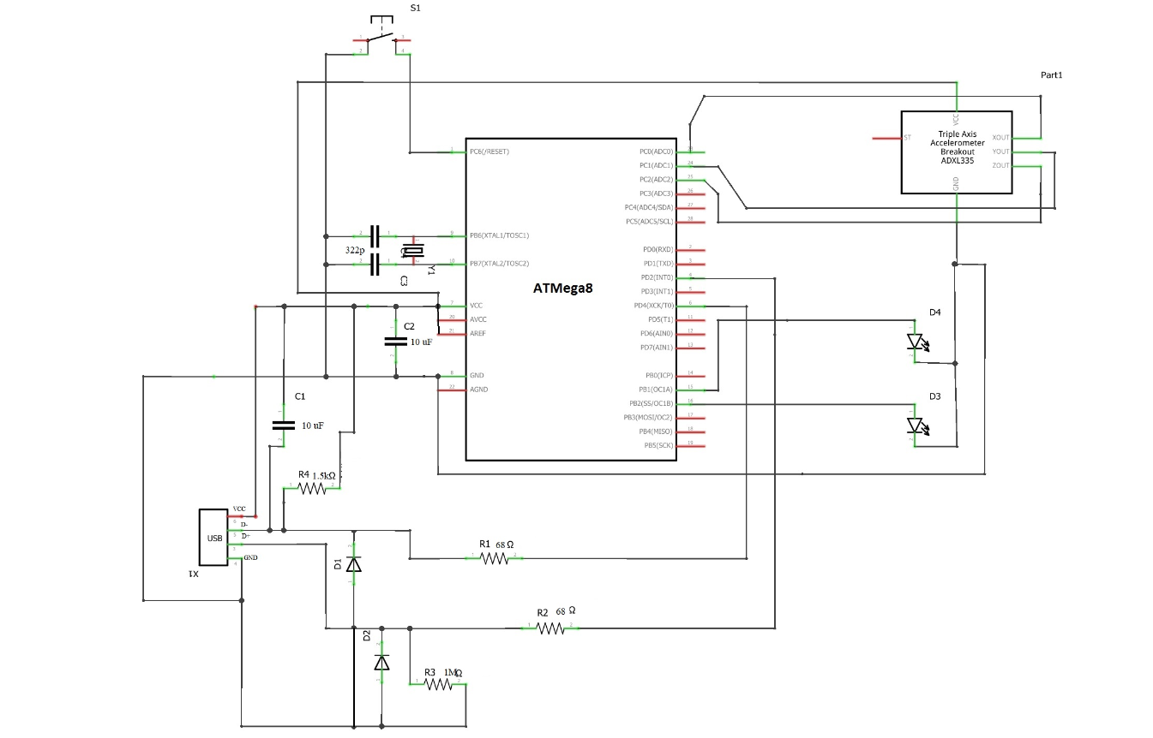

**Schematic of the circuit diagram showing connection of USB,ATMEGA8 Microcontroller and Accelerometer**

**2.ACTUAL HARDWARE CIRCUIT CONNECTION SNAP**

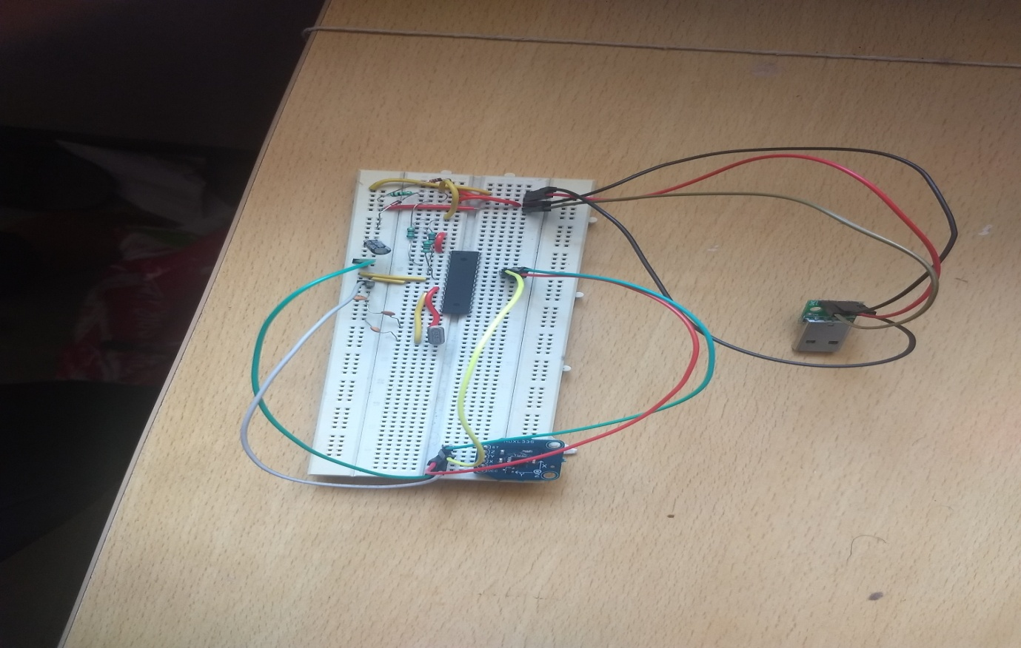

* **FIRMWARE AND ITS BUILD PROCESS**